DATA FLOW DIAGRAMS
AND USER STORIES
Book Doctor Management System
A Full-Stack Healthcare Appointment Management Platform (MERN Stack)
Prepared by: R. Thimme Gowd & Team
Yringam Rajesh • Karanam Sreenivasulu
Date: 14 July 2026

1. Introduction
This document presents the Data Flow Diagrams (DFDs) and User Stories for the Book Doctor Management System — a full-stack MERN (MongoDB, Express.js, React.js, Node.js) healthcare appointment platform that connects Patients, Doctors, and Administrators through secure, role-based dashboards using JWT authentication and bcrypt password encryption.
The Data Flow Diagrams model how information moves between external entities, internal processes, and data stores within the system. The User Stories translate the system's functional requirements — confirmed through the project's User Acceptance Testing (UAT) — into role-based statements of user need, each mapped to its corresponding acceptance criteria and UAT test case for traceability.

2. Data Flow Diagrams

2.1 DFD Level 0 — Context Diagram
The context diagram represents the Book Doctor Management System as a single process and shows its interaction with the three external entities: Patient, Doctor, and Administrator.
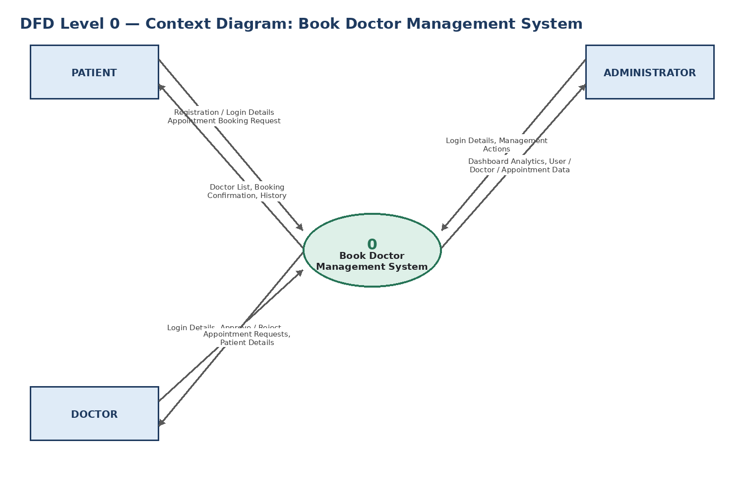
Figure 1: DFD Level 0 — Context Diagram
Key interactions:
- Patient → System: registration/login details, appointment booking requests; System → Patient: doctor list, booking confirmation, appointment history.
- Doctor → System: login details, approve/reject decisions; System → Doctor: appointment requests, patient details.
- Administrator → System: login details, management actions; System → Administrator: dashboard analytics, user/doctor/appointment data.

2.2 DFD Level 1 — Detailed Process Breakdown
The Level 1 diagram decomposes the system into five major processes and two data stores, showing how data flows between external entities, processes, and stored records.
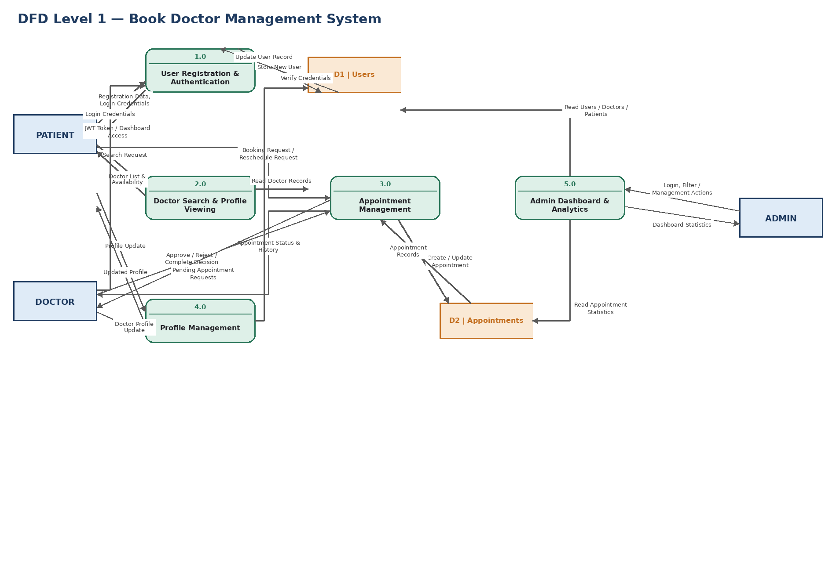
Figure 2: DFD Level 1 — Detailed Process Breakdown
Processes:
- 1.0 User Registration & Authentication — handles account creation, login, and JWT issuance; reads/writes to D1 Users.
- 2.0 Doctor Search & Profile Viewing — retrieves doctor records from D1 Users for patient browsing.
- 3.0 Appointment Management — handles booking, approval, rejection, rescheduling, and completion; reads/writes D2 Appointments.
- 4.0 Profile Management — updates patient and doctor profile data in D1 Users.
- 5.0 Admin Dashboard & Analytics — aggregates data from D1 Users and D2 Appointments for administrator reporting.
- D1 | Users — stores Admin, Doctor, and Patient account records.
- D2 | Appointments — stores appointment booking records including patient, doctor, date, time, reason, and status.

3. User Stories
Each user story below reflects a functional requirement of the Book Doctor Management System, drawn from the project's scope of work and validated through User Acceptance Testing. Acceptance criteria describe the observable, testable outcome expected for the story to be considered complete.

3.1 Patient User Stories
ID | User Story | Acceptance Criteria | Related Test Case
US-P01 | As a patient, I want to register a secure account with my personal details so that I can access the platform to book appointments. | Registration form captures first name, last name, email, phone, password, and role; password is stored encrypted (bcrypt); user is redirected to Login on success. | TC-001
US-P02 | As a patient, I want to log in with my registered email and password so that I can access my personalized dashboard. | Valid credentials generate a JWT token and redirect the patient to the Patient Dashboard; invalid credentials are rejected with an error. | TC-002
US-P03 | As a patient, I want to view a list of available doctors with their specialization, qualification, and experience so that I can choose the right doctor for my needs. | Doctors page lists all doctors with specialization, qualification, experience, and availability status. | TC-003
US-P04 | As a patient, I want to find and book an appointment with an available doctor without calling the clinic so that I can save time and effort. | Patient can select a doctor, choose a date/time, enter a reason, and submit; appointment is created with status 'Pending' and appears in Appointment History. | TC-004
US-P05 | As a patient, I want to view my complete appointment history so that I can track past and upcoming appointments and their statuses. | Appointment History page lists all past and upcoming appointments with accurate status (Pending / Confirmed / Completed / Cancelled). | TC-006
US-P06 | As a patient, I want to update my profile information so that my contact details stay accurate. | Profile changes to name/phone are saved to the database and persist after re-login. | TC-008
US-P07 | As a patient, I want the system to prevent me from double-booking the same doctor and time slot so that scheduling conflicts are avoided. | Attempting to book a doctor at an already-booked date/time is flagged or rejected by the system (currently open as Bug BG-001, High severity). | TC-010

3.2 Doctor User Stories
ID | User Story | Acceptance Criteria | Related Test Case
US-D01 | As a doctor, I want to log in securely so that I can access my dedicated dashboard. | Valid doctor credentials generate a JWT token and route to the Doctor Dashboard. | TC-002
US-D02 | As a doctor, I want to view and manage my appointment requests from a dashboard so that I do not miss patient bookings. | Doctor Dashboard > Appointments lists all pending, confirmed, completed, and cancelled appointments for that doctor. | TC-005
US-D03 | As a doctor, I want to approve or reject pending appointment requests so that only confirmed bookings proceed. | Selecting Approve/Reject updates appointment status to 'Confirmed' or 'Cancelled' and the change is visible on both Doctor and Patient dashboards. | TC-005
US-D04 | As a doctor, I want to mark an appointment as completed once the consultation is finished so that records remain accurate. | Appointment status can be updated to 'Completed' via PUT /api/appointments/:id/status and reflects in appointment history. | TC-005 / TC-006
US-D05 | As a doctor, I want to update my profile (specialization, hospital, availability, consultation fee) so that patients see current, accurate information. | Profile edits are saved and immediately reflected on the patient-facing Doctors list. | TC-008

3.3 Administrator User Stories
ID | User Story | Acceptance Criteria | Related Test Case
US-A01 | As an administrator, I want to log in with elevated privileges so that I can access system-wide management controls. | Valid admin credentials generate a JWT token and route to the Admin Dashboard; access is denied for non-admin roles. | TC-002 / TC-009
US-A02 | As an administrator, I want a centralized dashboard showing real-time statistics on users, doctors, patients, and appointments so that I can monitor system activity. | Admin Dashboard analytics load correctly and match underlying database records. | TC-007
US-A03 | As an administrator, I want to view all doctors and all patients in the system so that I can manage system records centrally. | GET /api/admin/users returns complete, accurate lists of doctors and patients for review. | TC-007
US-A04 | As an administrator, I want to view all appointments across the platform so that I can track overall booking activity and identify issues. | GET /api/admin/appointments returns all appointments with patient, doctor, date, time, and status. | TC-007
US-A05 | As an administrator, I want role-based access control enforced on protected routes so that only authorized users can reach admin or doctor areas. | Unauthenticated or wrongly-roled access attempts to /admin or /doctor are blocked and redirected to Login or shown an unauthorized message. | TC-009

4. Traceability Notes
All user stories above map to test cases executed during the UAT cycle (07 July 2026 – 13 July 2026), documented in the UAT_BookDoctor record. Nine of ten test cases passed; one defect (BG-001 — double-booking, High severity) remains open and is recommended for resolution prior to production release, corresponding to User Story US-P07.
This traceability ensures every documented user need has a corresponding verification step, supporting confidence in the system's readiness for deployment once the open defect is resolved.

